Name: Jessie Fischer Date: March 1, 2009

# Model Research Paper

## Free Blacks in the North in the Early Nineteenth Century

In the 1800s, there was a group of Americans who were prohibited from living in certain states. They were routinely insulted and sometimes physically attacked when they walked on the streets; they were assumed to be inferior to other Americans; and they lived in such poor conditions that many of their babies died in infancy—and yet they were called “free.” They were the free blacks of the slavery era—African Americans who were not enslaved, typically because their masters had freed them, their parents, or their ancestors. However, they were only free in the sense that no one legally owned them. They lived in both the North and the South, but perhaps surprisingly, they often led harder lives in the North. Despite suffering from oppressive discrimination, free blacks in the North managed not only to survive but to build a community that helped them thrive.

#### Economic and Employment Impediments

In the North, the economic barriers facing free blacks were severe. Because of prejudice, free black men found it especially hard to find employment in skilled trades such as construction. White workers often refused to work alongside blacks. In Cincinnati, a city that is just across the Ohio River from the then-slave state of Kentucky, the president of a union was put on trial by his organization for taking on a black apprentice (Curry 19). In New York City, white dock workers used violence to keep black men from obtaining jobs on the docks. As a result of such attitudes and behavior, 87 percent of the employed African Americans in that city in the 1850s worked in menial occupations (Takaki, Iron Cages 111). In 1830, a writer who called himself “a Colored Philadelphian” said, “If a man of color has children, it is almost impossible for him to get a trade for them, as the journeymen and apprentices generally refuse to work with them” (qtd. in Curry 19). A young free black man of that era wrote, “Shall I be a mechanic? No one will employ me; white boys won’t work with me” (Takaki, A Different Mirror 110). To feed themselves and their families, most free black men in the North took whatever work they could find as servants, day laborers, or sailors. Women often worked as maids, cooks, or laundresses (“African American History”).

#### Poor Living Conditions, Segregation, and Violence

When people cannot find good jobs, the lack of money forces them to live in squalid conditions; and the combination of overcrowding, poor sanitation, and inadequate diet can result in disease and death. A large proportion of northern free blacks faced housing discrimination and were forced to live in urban slums, “in alleys and on closed courts, or crammed into the rear portion of narrow lots” (Curry 79). In many ways, the living conditions faced by these free people was as bad as or worse than those faced by prisoners. Even more prosperous blacks, who had managed to achieve success in business or the professions, could not live in affluent neighborhoods because whites feared a loss of property value (Africans in America). In addition, discrimination had a more far-reaching effect than just where families could live. A study in Philadelphia in 1846 found that almost all babies in impoverished African American families died in infancy (Africans in America).

Moreover, jobs were far from the only part of daily life in which free blacks encountered prejudice. They faced segregation and hostility at almost every turn. Free blacks in the North were routinely refused admission to, or placed in segregated sections of, hotels, restaurants, theaters, and streetcars. Jail cells, hospitals, workhouses for the poor, cemeteries, fairs, and even the New York City zoo were segregated (Curry 91–93). In 1818, white volunteer firefighters in Philadelphia refused to allow black men to form a volunteer company for their own neighborhood—a completely peaceful, useful activity (Curry 93). The situation was similar to what existed in the South under “Jim Crow” laws—laws permitting segregation—during the early twentieth century. In fact, in the judgment of historian Margaret Washington, “The whole idea of Jim Crow and segregation of the races really originates in the North” (Africans in America).

For free black people in the North, just walking down the street was risky. For little or no reason, whites could push them from the sidewalk, spit at them, ridicule them, stone them, and submit them to other kinds of violence such as having poisonous gas thrown into their churches or being shoved into barrels of boiling tar (Curry 93–94). In city after city between 1820 and 1850, mobs of whites attacked people in black neighborhoods. For example, the antiblack Snowtown Riot in Providence, Rhode Island, in September 1831, lasted four days. Cincinnati experienced a major antiblack riot almost every year from 1834 to 1842, including a three-day “reign of terror” in 1841 during which whites fired a cannon at blacks (Franklin and Moss 152–153; Curry 96–111).

Discrimination was not only the result of individual or mob action, however. During the early 1800s, the laws of many northern states promoted segregation. Several free states prevented African Americans from exercising such basic rights as the right to vote, assemble, travel, take up residence, and to testify in court and serve on juries. The Ohio state constitution of 1802 took away many of the rights free blacks had previously enjoyed, including the right to vote. New York, Connecticut, and Pennsylvania also deprived free blacks of voting rights. According to historians John Hope Franklin and Alfred A. Moss Jr., “There was no extensive Negro voting anywhere after 1830” (141).

#### Black Codes

Another kind of law discriminating against free blacks was called a “Black Code.” Black Codes were sets of legal requirements that put extra burdens on black people. For example, in 1807, Ohio enacted a Black Code that required African Americans to post a $500 bond to guarantee that they would behave peaceably and that they would support themselves. Going one step further, some states passed “black exclusion laws” that prohibited free blacks from residing in, or in some cases even entering, those states. States with black exclusion laws included Illinois, Indiana, Michigan, Wisconsin, and Iowa—states that were newly opening up lands for settlement (Africans in America). The message was clear: White settlers did not want black settlers living nearby.

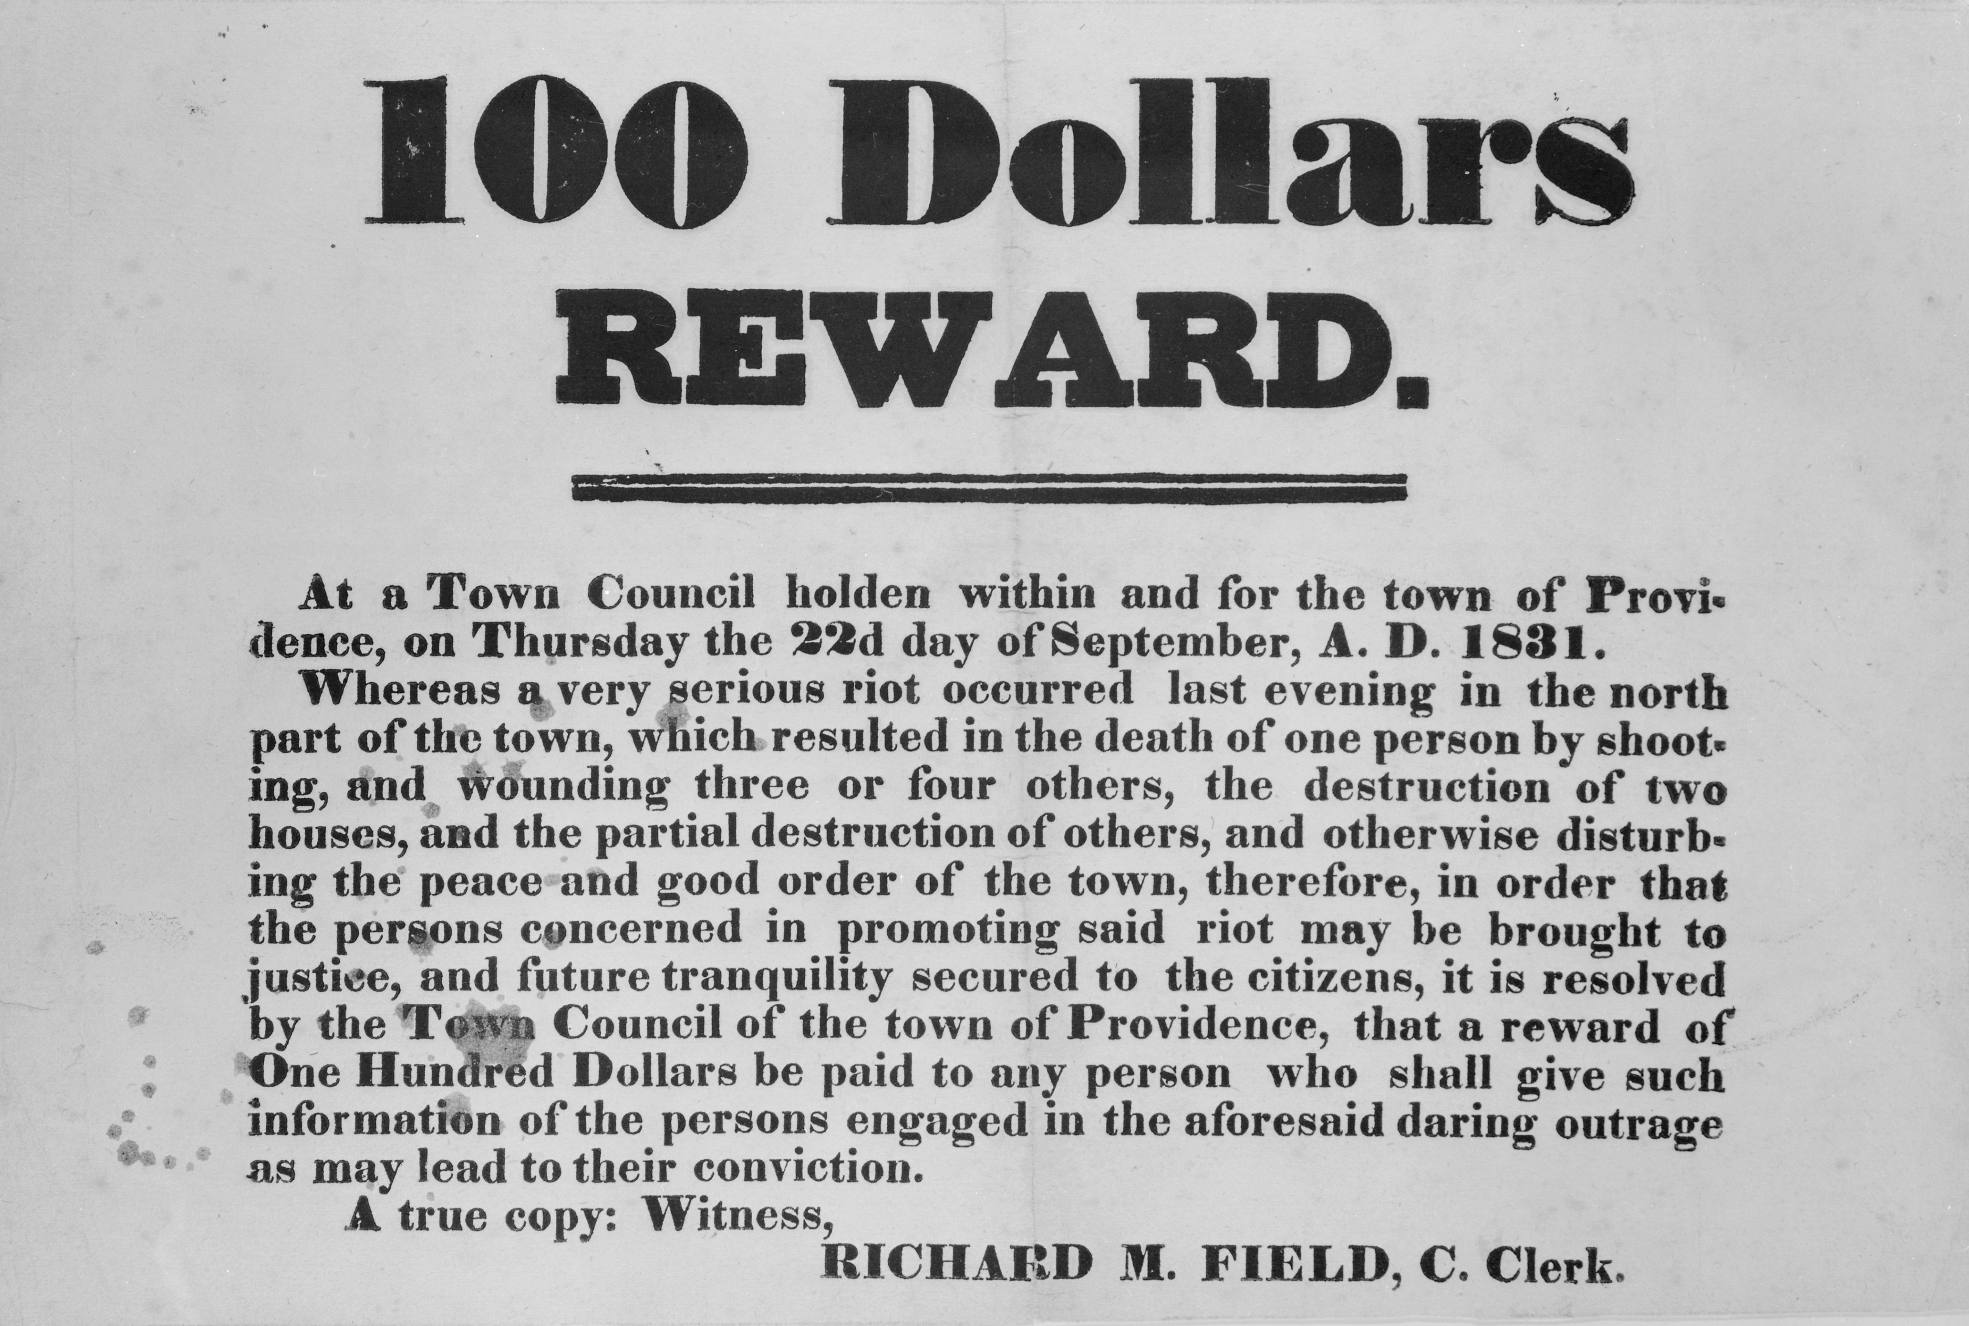

RHODE ISLAND HISTORICAL SOCIETY

During the Snowtown Riot of September, 1831, an angry mob attacked African-American homes and businesses for two days in Providence, Rhode Island. After the violence ended, city authorities posted reward notices like this broadside issued by the town of Providence, Rhode Island on September 22, 1831.

Why would northern states, where slavery was illegal, refuse to allow free blacks to live there? The answer lies in the complicated views of race that many white people held at the time. White people sometimes believed that slavery was immoral but still felt that black people were inferior. Therefore, while they opposed slavery, they also opposed integration. The fact that a state forbade slavery did not mean that it welcomed black people. Indeed, sometimes the opposite was true. Some white northerners thought that abolishing slavery was a good idea because it would separate the races. They saw that in the slave states, blacks and whites lived in close physical proximity on the same plantations and worked in the same towns. Many northern whites feared that integration would lead to interracial marriage. (There were laws against such marriages in Indiana and Illinois.) Even some abolitionists were motivated by a fear that slavery would lead to interracial breeding (Takaki, Iron Cages 114–115).

Putting together job discrimination, legal segregation, poverty, prejudice, and violence, the sum total of the forces working against free blacks was great. In Franklin and Moss’s opinion, “toward the end of the slave period the distinction between slaves and free Negroes had diminished to a point where in some instances it was barely discernible” (139). These two historians term the status of free blacks in that era “quasi-free” (136), and Africans in America calls it “a strange state of semi-freedom.”

#### A Community Emerges

It would be a grim story except for one huge, triumphant fact: The free blacks endured and survived against massive odds. Both individual effort and community solidarity contributed to create success stories. Through immense struggle, some African American entrepreneurs, professionals, and craftsmen prospered. To note one example, Stephen Smith of Philadelphia, a lumber merchant, was worth $100,000, an extremely large sum at the time. He owned 58 brick houses in that city as well as buildings in nearby towns (Curry 38). Francis “Frank” Johnson, a musician, conductor, and composer, “dominated the field of military and dance band music in Philadelphia in the second quarter of the nineteenth century” (Curry 23). African Americans were doctors, teachers, ministers, clerks, and they accounted for more than 100 types of skilled workers (Curry 23; Franklin and Moss 143). They were usually paid less than their white counterparts, and many could only practice their trades part time, but they persevered.

Free blacks who managed to acquire wealth also worked hard to improve their communities. In the midst of oppression, institutions arose that focused the fight against injustice. Churches were important gathering places, and ministers became influential spokesmen for the cause of justice. Occasionally, black ministers even preached in white churches (Franklin and Moss 146–147). Although schools were segregated, free black students learned eagerly, and some of them went on to prestigious colleges such as Amherst, Bowdoin, and Oberlin (Curry 149–150). Free black writers and journalists penned their views, and newspapers such as Freedom’s Journal and the Colored American raised their voices against discrimination (“African American History”). An “African Theater” existed in New York in the 1820s. Literary societies met to discuss ideas, often focusing on the idea of freedom. Mutual aid societies and orphanages helped the needy. Masonic lodges, in particular, thrived in African American communities. Conventions of free black activists blossomed to adopt strategies of political action. Political groups, such as the Law and Order Party in Providence, strove for African American suffrage (Curry 219). And, in the face of violence by white attackers, free blacks formed vigilance committees to guard their neighborhoods and fight back.

| **City** | **Prominent African-American Neighborhoods (Pre-Civil War)** |
| --- | --- |
| New York City | The 5th and 6th Wards of Lower Manhattan and Fort Greene, Brooklyn |
| Philadelphia | South Philadelphia and Greenville (present-day West Philadelphia) |
| Boston | The north slope of Beacon Hill |
| Cincinnati | Bucktown (east of downtown) and Little Africa (western riverfront) |
| Providence | Hard Scrabble, Snow Town, and College Hill (present-day downtown) |

Thus the story of free blacks of the North is one of struggle against tremendous obstacles, but ultimately it is a story of victory. In cities such as New York, Philadelphia, and Boston, free blacks founded lasting communities in which the people who came after them prospered, created, and overcame. Americans today may wonder how the free blacks of that time were able to endure. One part of the answer may be that the free blacks of the North “shared the nineteenth-century version of the ‘American Dream’” (Curry xix). They knew that slaves could become free, and they foresaw that freedom could expand greatly beyond the half-freedom that they knew. They believed in their own abilities and believed that in spite of everything, America was the place where their efforts could bear fruit. At times they may have despaired. As Curry says, “to most urban free blacks it must surely have seemed that they had been able to grasp but the shadow of the dream.” Nevertheless, Americans today can look back and know that the free blacks succeeded. In the process, they passed down a legacy that benefits the entire nation. Free blacks may have been hindered in their opportunities, but their contributions to the future were vast.

WORKS CITED

“African American History.” Microsoft Encarta Online Encyclopedia. 2008. Web. 12 Nov. 2008.

Africans in America: America’s Journey through Slavery. WGBH Interactive for PBS Online, 1999. Web. 13 Nov. 2008. <http://www.pbs.org/wgbh/aia?part4/4narr3.html>.

Curry, Leonard P. The Free Black in Urban America, 1800–1850. Chicago: U of Chicago P, 1981. Print.

Franklin, John Hope, and Alfred A. Moss Jr. From Slavery to Freedom: A History of Negro Americans. 6th ed. New York: Knopf, 1988. Print.

Takaki, Ronald. A Different Mirror: A History of Multicultural America. Boston: Little, 1993. Print.

---. Iron Cages: Race and Culture in 19th-Century America. New York: Knopf, 1979. Print.