# Model Research Paper

## William Wordsworth: Contrasting Nature and Industry

One day in 1798, the poet William Wordsworth went walking along the Wye River in England. The landscape was beautiful, and he wrote about it in one of his most famous poems, “Lines Composed a Few Miles Above Tintern Abbey, on Revisiting the Banks of the Wye during a Tour, July 13, 1798.” He had visited the same place five years earlier, but between the two visits he had lived a lonely, weary life in the city of London. Seeing the Wye valley again brought him feelings of freedom and joy. In the poem, he calls those feelings “sensations sweet” (Wordsworth 27).

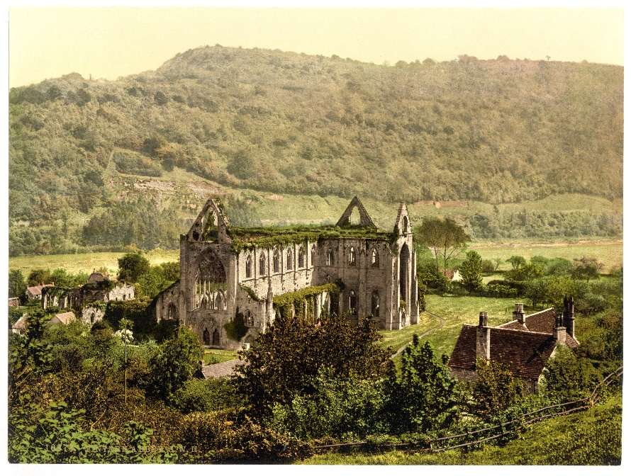

Library of Congress, Prints & Photographs Division, Photochrom Collection, LC-DIG-ppmsc-08902

Tintern Abbey, a twelfth century Cistercian monastery, was an inspiration  
 to William Wordsworth when he visited it in the late 1700s.

The contrast between city and country was a dramatic one for Wordsworth because he lived at the time of the Industrial Revolution, when new inventions were leading to the rapid growth of factories and cities. In his poems, Wordsworth contrasts nature with the negative effects of the Industrial Revolution. This contrast helps readers understand the society in which Wordsworth lived.

#### The Industrial Revolution’s Impact

The Industrial Revolution was a bulldozer of change that swiftly and permanently altered both the landscape and the economy of Britain. The nation was changing from an agrarian economy, relying mostly on farming, to an industrialized economy, relying on machinery (King 19, 46). New inventions such as the iron bridge, first built in 1779, and improved canals were making long-distance transportation easier. Meanwhile, inventions in the textile field and the development of the steam engine led to the swift growth of urban factories, severely hurting small-scale traditional weavers and pulling many more workers into London and other cities. People left their farms and small towns and flocked to the cities to look for work. As a result, the cities became overcrowded, “cramped and grim” (King 46).

William Wordsworth and many of his poetic contemporaries were sensitive to the changes that the Industrial Revolution brought. Wordsworth was one of the founders of a movement in poetry called romanticism. Romanticism has nothing to do with romantic love. Instead, the Romantics were part of a poetic movement that spoke for the value of the individual over society, emotion over reason, and personal fulfillment over wealth. They also found much of their inspiration in nature. In keeping with these views, the Romantics protested against many of the technological advances that dominated the Industrial Revolution because they felt that technology and the change it brought threatened individual happiness. They “opposed the dehumanizing growth of industrialism and commerce, and the brutalizing effect of dull, repetitive labor practices” (King 50). Wordsworth, who spent many years in the remote, picturesque Lake District of England, was a Romantic poet who was especially attuned to the wisdom found in nature (King 9).

Wordsworth’s opposition to industrial development can be seen in his book-length poem *The Excursion*. For example, in a passage from that poem, Wordsworth describes the changes in a small hamlet that has experienced industrialization. The place becomes “a huge town… / O’er which the smoke of unremitting fires / Hangs permanent…” The passage in *The Excursion* states that the change occurs “at social industry’s command” (120, 125–126). The tone of the passage is one of deep regret, perhaps even outrage. Wordsworth is clearly displeased by the effect of industry on the town.

#### The Value of the Natural World

To escape the influence of industrialization, Wordsworth sought the peace and beauty of nature. In many of his poems, he describes the beauty of nature and the healing power that he believed nature exerted over his spirit. One poem that expresses this feeling is “Lines Composed a Few Miles Above Tintern Abbey,” the poem Wordsworth wrote during his walk along the Wye. One critic has called this poem “the most personal, and at times the most impassioned” poem Wordsworth wrote in praise of nature (Pinion 81). In the following lines, the poet reveals that nature has a profound influence on his sense of well-being. Nature fills him

With tranquil restoration:—feelings too

Of unremembered pleasure: such, perhaps,

As have no slight or trivial influence

On that best portion of a good man’s life,

His little, nameless, unremembered, acts

Of kindness and of love. (30–35)

In this passage Wordsworth says that nature inspires him to be kind and loving. He gives nature credit for the goodness inside him. Later in the poem, he calls nature “The anchor of my purest thoughts, the nurse, / The guide, the guardian of my heart, and soul / Of all my moral being” (109–111).

In contrast, he paints a dismal picture of life in human society. People provide the “evil tongues, / Rash judgments…sneers of selfish men, / …greetings where no kindness is” and the “dreary” experiences “of daily life” (128–131). Wordsworth is saying that human society is a place where evil can be found. Nature, he believes, protects sensitive individuals, such as poets, from the evil influence of society, and especially industrial society.

#### The Ugly Side of City Life

For Wordsworth, selfishness and unkindness go hand-in-hand with the growth of industrial cities. He felt that the Industrial Revolution resulted not just in harm to the environment but in emotional and moral harm. Biographer Hunter Davies writes that Wordsworth “could see quite clearly the ravages created in family life by the Industrial Revolution and the new factories: the all-night shifts, the abuses of child and female labour, the dangers to health and morals and the breakdown in rural life as people fled from the country to the towns” (229–230).

Although Wordsworth does not directly mention industrialization in “Lines Composed a Few Miles Above Tintern Abbey,” he was surely aware of the influence of that social change as he walked along the banks. The Wye River valley and the village of Tintern, which sat on its banks, were being threatened by industrial growth during that time. The Wye was a center for the smelting of iron ore in furnaces. The fuel for the furnaces was charcoal, which was obtained by burning oak trees that grew in the local woods. The result of the charcoal smoke was air pollution. Two travel writers from Wordsworth’s time provide evidence of how unpleasant the pollution was. One writer was Julius Caesar Ibbetson, who wrote about the topic in 1792. He observed “a number of smelting houses on the banks of the Wye, and much too near the abbey; clouds of thick black smoke, and an intolerable stench…disgusting to the utmost degree, and entirely destroying the landscape” (qtd. in Rzepka 1). A second traveler who made similar comments was William Gilpin, author of the 1770 volume Observations on the River Wye (Rzepka 1–2).

Wordsworth viewed the same scene that Ibbetson and Gilpin wrote about. In “Lines Composed a Few Miles Above Tintern Abbey,” Wordsworth does not describe the pollution directly; he prefers to leave it unmentioned, as if he is turning his head away from it. Instead, he contemplates the wholesome beauty that the region also offers. He presents the landscape of the Wye to the reader as if it were still unspoiled. Describing nature was Wordsworth’s way of escaping from the ugly aspects of the world. As literary historian Neil King puts it, “Wordsworth’s reaction to the increasing commercialization and industrialization of his time was to draw inspiration from the perception of an exterior landscape” (35). One example of the poet’s escape from industrial ugliness into natural beauty was the hike that resulted in “Lines Composed a Few Miles Above Tintern Abbey.” Walking upriver from the ugliness of the smelting furnaces and the smoke, he was able to concentrate on the beauty of the running water and the woods.

#### Nature and the Human Soul

“Lines Composed a Few Miles Above Tintern Abbey” is not the only poem in which Wordsworth expresses the power of nature. Another of Wordsworth’s poems, “Lines Written in Early Spring,” suggests that the beauty of nature leads him to recall the harm humankind has done to the world and to humans themselves:

I heard a thousand blended notes,

While in a grove I sate reclined,

In that sweet mood when pleasant thoughts

Bring sad thoughts to the mind.

To her fair works did Nature link

The human soul that through me ran;

And much it grieved my heart to think

What man has made of man. (1–8)

The phrase “what man has made of man” means the harm the human race has done to itself. It implies that when humans created the industrial world, their own creation turned against them. Wordsworth is so troubled by humanity’s actions that he uses the phrase “what man has made of man,” twice in the poem, including in its final line. It is the key phrase of the poem, expressing the “sad thoughts,” which Wordsworth mentions in the first stanza, that he cannot avoid even when he is immersed in natural beauty.

| Wordsworth's View of Life in Industrialized Cities | Wordsworth's View of Life in the Natural World |
| --- | --- |
| Air and noise pollution | An unspoiled, peaceful environment |
| Ugly factories | Beautiful landscapes |
| Poor and dangerous living conditions | Healthy and safe housing in small towns and villages |
| Abuses of child and women laborers | Respect for young people and women |
| Corruption, immorality, and materialism | Moral decency and spirituality |

Wordsworth did not merely like or love nature; he had almost religious feelings about it. He sees a “holy plan” in nature, according to “Lines Written in Early Spring” (22). In “Lines Composed a Few Miles Above Tintern Abbey,” he refers to himself as a longtime “worshipper of Nature” (152). For Wordsworth, nature was “a power…a guide leading beyond itself” (Hartman 40), helping people achieve their highest potential. However, in “Lines Written in Early Spring,” human actions have given him “reason to lament” (23). The actions “grieved my heart,” that poem states (7). The contrast is stark and simple: In Wordsworth’s mind, nature is good and the industrial world is evil.

Wordsworth’s poetry balances two conflicting forces: nature and industrialization. Without a doubt, Wordsworth was on nature’s side. He lived at a time when society was leaving behind an old way of life and beginning a new way that he found unpleasant. He belonged to a poetic movement whose members objected to the industrial change and preferred the old, natural order of things. “The Romantics saw the need to fight for identity and individuality against the anonymity of the production process brought about by the coming of the machine” (King 49). Wordsworth fought for his own identity and individuality by escaping to a rural area far away from the huge city of London. Walking along rivers and lakes, he used his powers of poetic observation to try to achieve inner peace and to encourage readers to seek it for themselves. His poems praise such basic natural objects as hills and streams and make the reader feel their beneficial power. In contrast, when Wordsworth describes urban industry, he makes the reader feel its ugliness. In both his life and his writing, Wordsworth expressed love of nature and opposition to the mechanized world that was growing up around him.

**Works Cited**

Davies, Hunter. *William Wordsworth*. New York: Atheneum, 1980. Print.

Hartman, William. “The Romance of Nature and the Negative Way.” *Modern Critical* Views: *William Wordsworth*. Ed. Harold Bloom. New York: Chelsea House, 1985. 37–54. Print.

King, Neil. *The Romantics*. New York: Facts on File, 2003. Print.

Pinion, F. B. *A Wordsworth Companion*. New York: Macmillan, 1984. Print.

Rzepka, Charles J. “Pictures of the Mind: Iron and Charcoal, ‘Ouzy’ Tides and ‘Vagrant Dwellers’ at Tintern, 1798.” *Studies in Romanticism* 2:2 (2003). BNET. CBS Interactive. Web. 25 May 2009. <http://findarticles.com/p/articles/mi_hb297/is_2_42/ai_n29028557>.

Wordsworth, William. *Selected Poems*. Ed. John O. Hayden. London: Penguin, 1994. Print.