Semester Test
Name: | Date:
(4 points)
- Give a basic definition of the word government.
Score
Answer:

(8 points)
- Protection is one of the five major purposes of government. Briefly explain why protection is an important government purpose. Then briefly describe how the United States government fulfills that purpose.
Score
Answer:

(8 points)
- Diagram the three branches of the national government. List their duties. Identify a major institution in each branch.
Score

A. | B. Legislative branch | C.

(8 points)
- The chart on the next page tracks the route that a bill takes as it moves through Congress. Label each box or briefly describe what happens at that stage in the legislative process. There are 10 boxes on the chart. You will receive 1 point for each correctly filled-in box, with a maximum score of 8 points.
Score
(Hint: you may find it easier to remember if you draw arrows indicating how a bill
progresses from the House through the stages of becoming a law.)

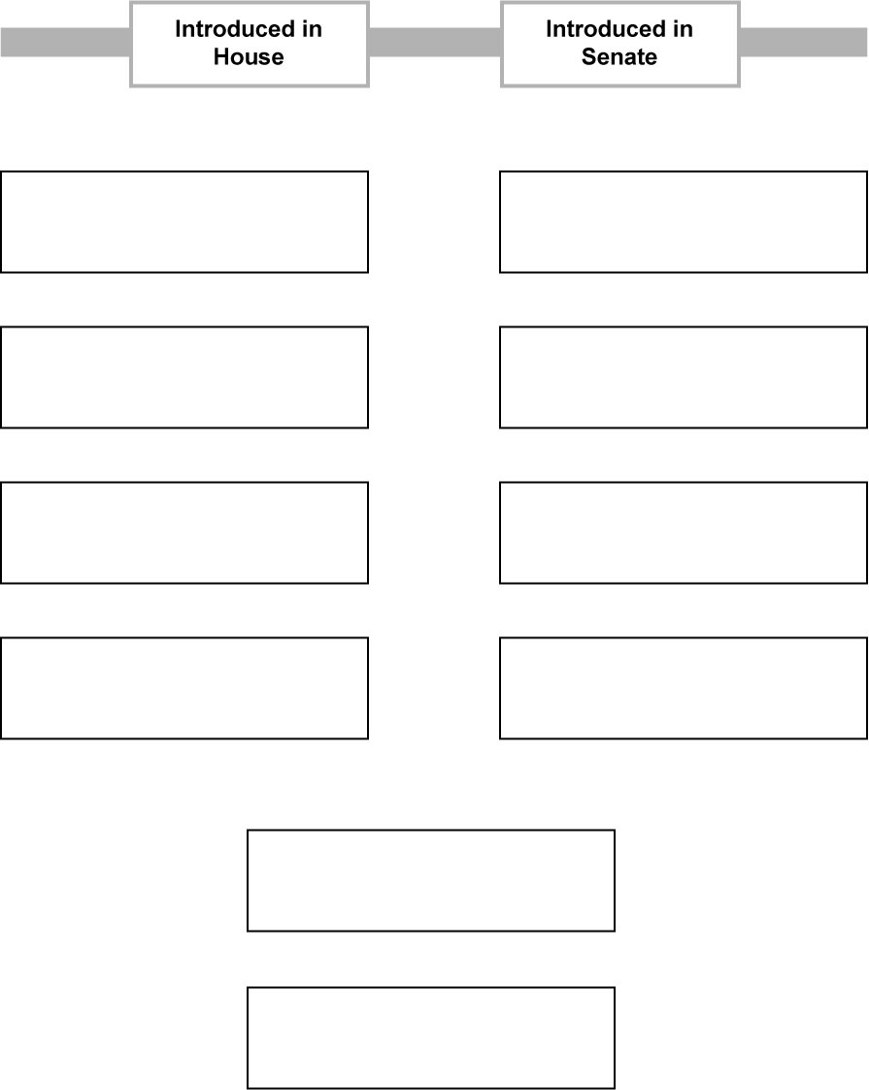

(8 points)
- The right to vote has been extended by several constitutional amendments. Write a few words explaining what each of these amendments did.
Score

Fifteenth:
Nineteenth:
Twenty-fourth:
Twenty-sixth:

(8 points)
- Nations with proportional representation tend to have multiparty political systems. Nations with first-past-the-post voting tend to have two-party political systems.
Score

How do different types of voting systems lead to different types of party systems?
Answer:

(8 points)
- Government policymaking is divided into several realms. One important policy realm is economic policy, which focuses on business cycles. The chart below shows the business cycle.
Score
Label the chart.


Identify two policies that the federal government can follow in order to make the business cycle less disruptive.

Policy 1:
Policy 2:

(8 points)
- One important purpose of government is to protect the rights of the people. Americans have disagreed in the past about how best to protect rights.
Score

Why do many Americans believe that rights should be clearly stated and identified?

Why do many Americans believe that rights should be stated in broad or general terms?

(20 points)
- Chain Question: Created Equal. All three parts of this question build on each other, and should be addressed as parts of a whole.
Score

The Declaration of Independence declares that "all men are created equal."

Explain how this principle is expressed in the structure of the Constitution or the organization of the United States government.

Give an example of a linkage group that promotes or opposes this principle.

Give an example of how this principle has affected government policies in the modern era since 1945.

(20 points)
- Free Response
Score

"The state of California is a major world power. It has the 10th largest economy in the world, a population greater than Canada, and a worldwide influence on media and popular culture. It deserves its own seat in the United Nations."

Respond to this quotation in a 20-minute essay. Your response should discuss federalism, the definition of a nation, and the powers of state governments.
Your Score | ___ of 100

