EXTRA CREDIT FOR UNIT 4 (8 points)!

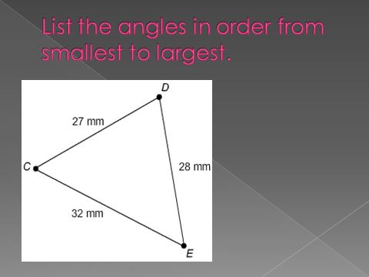

ECD