Name:

Date:

# Graded Assignment

## Unit Test, Part 2: Surface Area and Volume

Answer the questions below. When you are finished, submit this test to your teacher by the due date for full credit.

Total score: ____ of 39 points

(Score for Question 1: ___ of 12 points)

1. Jon started with a diagram like the one below and drew a three-dimensional figure by rotating the circle 360° about line *m*.

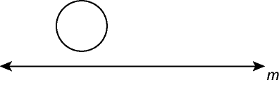

Nadia started with a diagram like the one shown below and drew a three-dimensional figure by rotating the right triangle *ABC* 360° about line *n*.

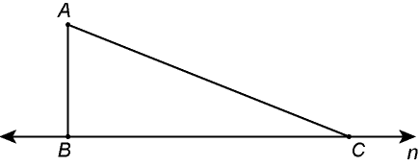

1. Name the three-dimensional figure created by each person.
2. Nadia remarked that her figure has an infinite number of planes of symmetry. Jon gave a sly grin and remarked that his figure has an infinite number plus one! After explaining the difference between his figure’s planes of symmetry and hers, Jon convinces Nadia that his figure does have one more than hers. How might Jon have explained this?

Answer**:**

(Score for Question 2: ___ of 12 points)

1. A triangular pyramid is defined by the points .The pyramid is then reflected over the *xz*-plane. The reflected image is then translated 3 units back, 2 units left, and 4 units up.
2. Write the general rule you use for the reflection.
3. Show the results of your calculations for the reflection.
4. Write the general rule you use for the translation. (Hint: Begin with the result of the rule for the reflection.)
5. Show the results of your calculations for the translation.

Answer:

(Score for Question 3: ___ of 15 points)

1. Rectangle *RECT* is rotated 360° about the *y*-axis.

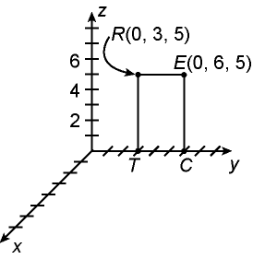

1. What is the resulting solid of revolution? Provide any key dimensions.
2. What is the surface area of the resulting solid of revolution? State the formula to be used, show all of your work, and use appropriate units in your answer.
3. What is the volume of the resulting solid of revolution? State the formula to be used, show all of your work, and use appropriate units in your answer.

Answer: