Name:

Date:

# Graded Assignment

## Unit Test, Part 2: Three-Dimensional Figures and Graphs

Answer the questions below. When you are finished, submit this test to your teacher by the due date for full credit.

Total score: ____ of 45 points

(Score for Question 1: ___ of 8 points)

1. Discuss the differences between the measurement of the surface area and the measurement of the volume of a right rectangular prism. Include the following topics in your discussion.
2. Description of regions that are measured
3. Units for each type of measure and why the units are different
4. Examples of when you would want to measure for each type of measure

Answer**:**

(Score for Question 2: ___ of 10 points)

1. The general equation of a plane is *Ax* + *By* + *Cz* = *D*, where *A*, *B*, *C*, and *D* are real numbers and *A* is nonnegative. Find the equation of the plane containing the points . Show each step of your process. Then graph the plane.

Answer:

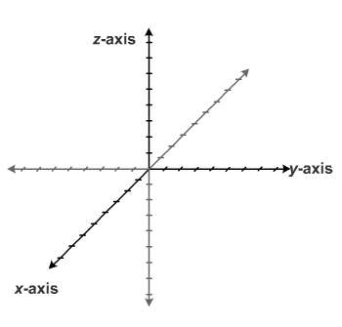

(Score for Question 3: ___ of 9 points)

1. Find the volume of the triangular prism shown in the diagram. The unlabeled point is . Outline your steps to explain the process you used.

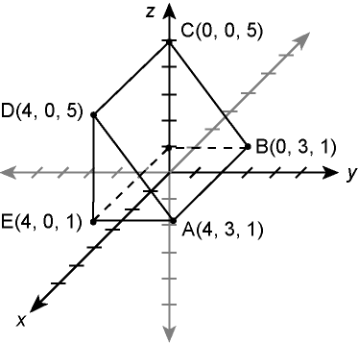

Answer:

(Score for Question 4: ___ of 10 points)

1. Plot three points and draw the line that has the following parametric equations. Show each step of your process.



Answer:



(Score for Question 5: ___ of 8 points)

1. Use the isometric grid to create an isometric drawing of a rectangular prism.

Answer:

