Geography Orientation Assignment

1. Copy the Map and Paste here to Show Mrs. Shane’s Travel and then Name Two places she visited. If you have trouble with the copy/paste or screen clip, let me know.

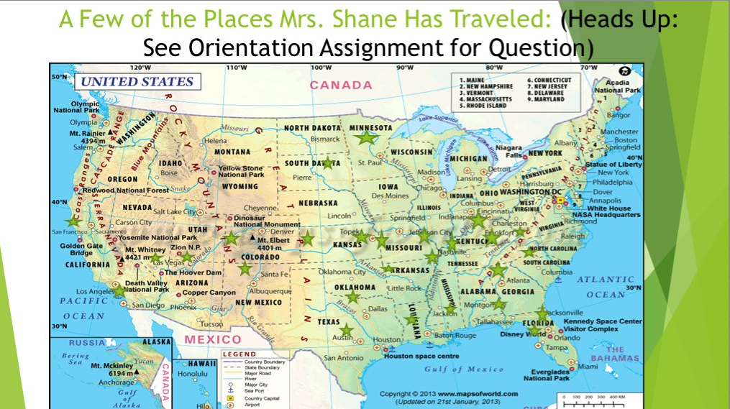

San Francisco/Golden Gate Bridge

Grand Canyon

Hoover Dam

Oklahoma

1. Where Do I find a copy of my Geography Syllabus?

In course materials

1. What Three Ways can I ask Mrs. Shane a question?

Email

Phone

Raise your hand Discussion Board

1. What is NOT plagiarism?

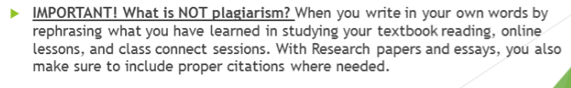

1. How many times should I post to a Discussion Board for full credit unless otherwise directed?

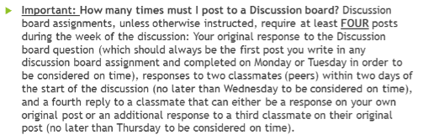

1. What two types of assignments must be submitted in the week assigned?

Discussions Board assignments

Class Connect assignments

1. How Do I name a file?

With the keyboard

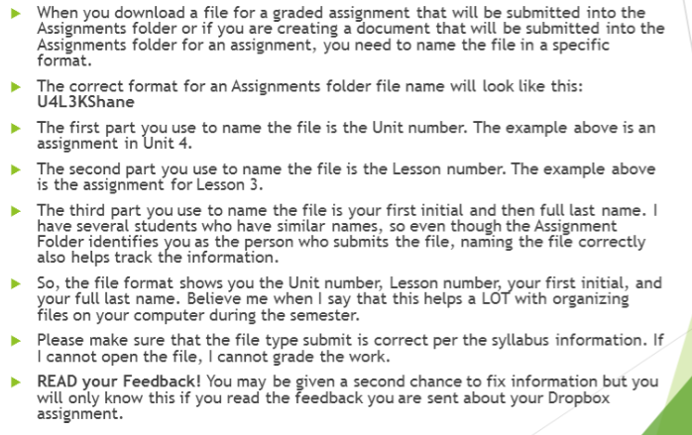

1. What are the Late and Lock Dates for This semester?

September 18th

October 23rd

November 27th

December 11th