Personal Finance Course Orientation Assignment

Fall 2016

***Complete the ENTIRE form in order to receive your full 15 pts for attending the course orientation. Submit to the assignment dropbox for grading.***

1. When are you assignments and quizzes due for the week?

Sunday at midnight

__________________________________

1. What is the **first** thing you should do if you are stuck on a concept and need help? (multiple choice)
   1. Call Mrs. Bryant
   2. Email Mrs. Bryant
   3. Look back through the online study/notes/practice problems

C

1. What days/time are our weekly class connect sessions?

Tuesdays and Thursdays at eleven am

______________________________

1. In order to have a quiz re-set, what criteria must occur? (multiple choice)
   1. Mrs. Bryant will never reset a quiz
   2. I can automatically retake a quiz one time
   3. Call Mrs. Bryant

B

***Please place your initials next to each statement below. By initialing, you understand my expectations of you as a student in my classroom. You agree to adhere to the rules and guidelines. If you have any questions, please feel free to kmail me.***

1. I will check my email at least once per day (Monday – Friday) and respond accordingly. _MJM_(initial here)
2. I understand the Personal Finance Graduation Requirement. I know I must pass each unit within the course material as well as pass the class and receive graduation credit. __MJM__ (initial here)
3. I will contact my teacher when I am struggling and work on a plan to improve. _MJM_(initial here)
4. I will pay attention to the class plan and class news and turn in assignments when due. If not, I will complete work by the checkpoint (understanding that a 25% late penalty will apply). _MJM_(initial here)
5. I will take advantage of my teacher’s re-teaching and small group help when I need help. _MJM__ (initial here)
6. Take a screen shot or Snip-It of the EverFi Account Setup Instructions located under Course Materials and paste it below.

Everfi Account Set Up

1. Go to [www.everfi.com/login](http://www.everfi.com/login).
2. Click on the blue ‘Register’ button if you do not have an account.

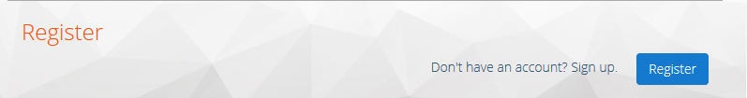

1. Enter the registration code: **8d20637d then click ‘next’.**

**If you are NOT new to EverFi (you have used EverFi for a previous course), you can just login and enter the class code in the ‘add a course’ option on the top right corner of the screen to have access to Personal Finance.**

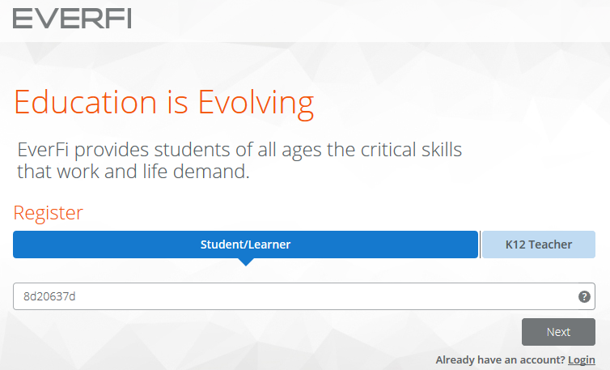

1. Click “student/learner”.

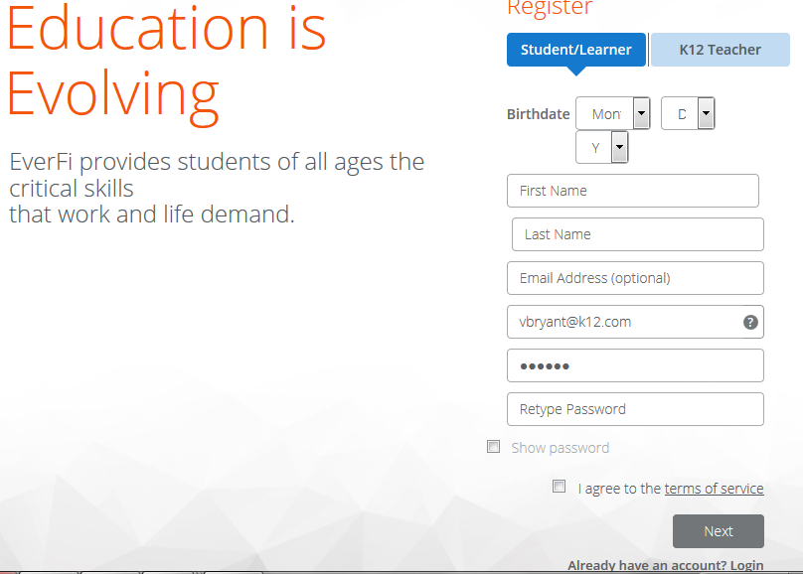

1. Create a unique username – try “firstlast” (Ex: “sarahpratt”, and add numbers if you need to (Ex: “sarahpratt13”.
2. Enter your email address if you have one. (email is optional, you do not need one to have an account)
3. Choose a password. Your teacher can reset it if you forget. (**Write your password down somewhere safe so you can access it later**.)
4. Check box “Agree to terms of Service”.
5. Click on the blue “Get Started” button in the bottom right hand corner of your screen.

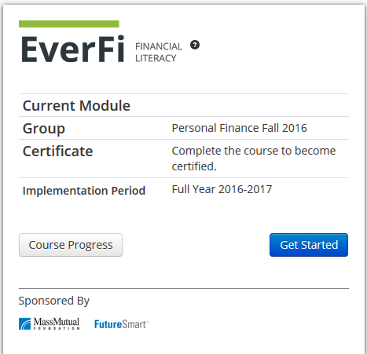

1. Complete the “EverFi Financial Literacy Survey 1” if you are asked too. (Not every student will be asked to complete this, it is a random survey.) Once you are finished with the survey you will click on the blue “click here to continue” button.

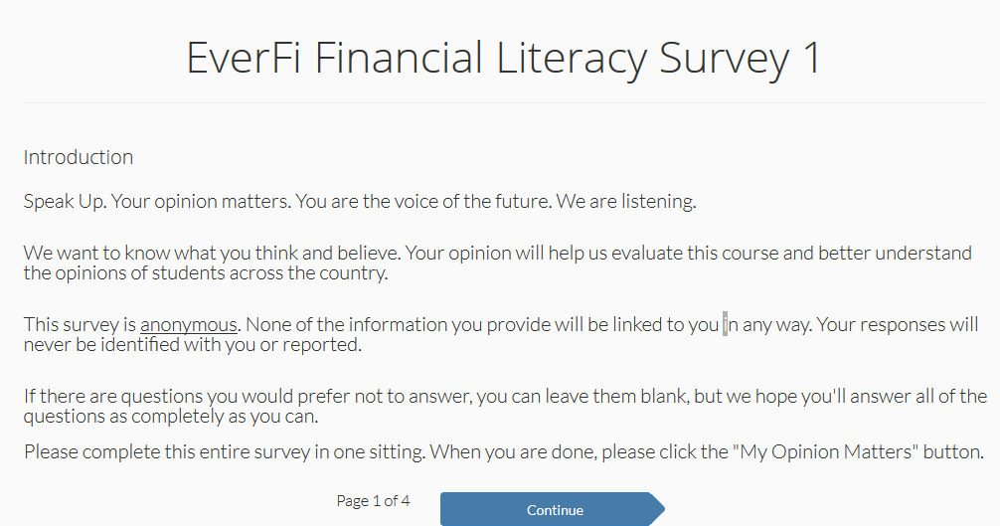

1. After completing the survey (if asked) click on “click here to continue”.

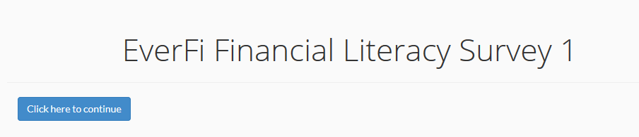

1. You may be asked to participate in the K-12 supplemental: Sports participation survey. If you were chosen at random, please complete.

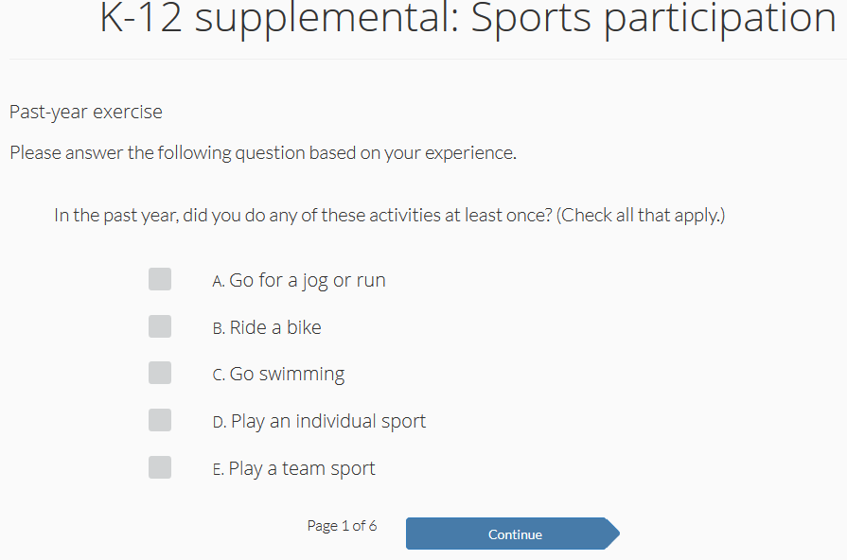

1. Welcome to the EverFi Financial Literacy course! Watch the intro video and click on the arrow to the right to continue to the next screen.

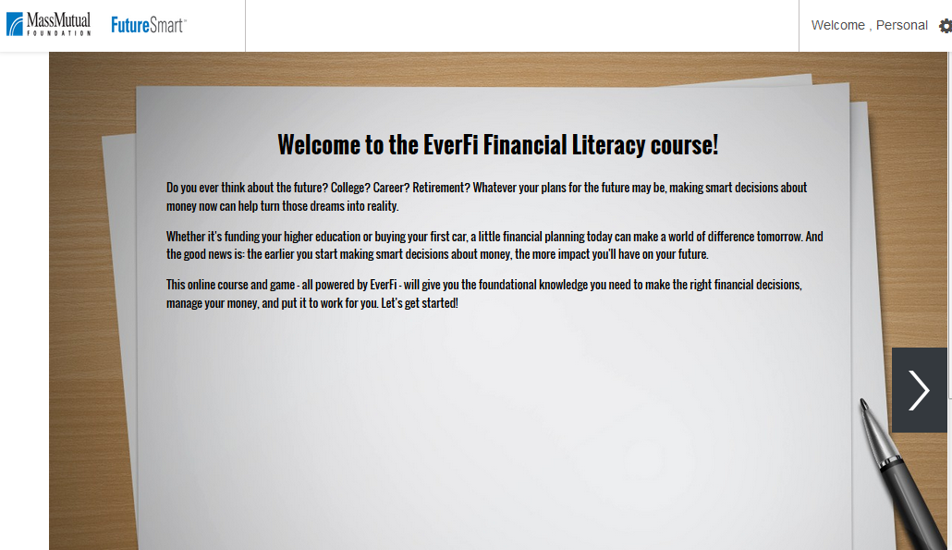

1. You can now choose a Lesson to begin.

